Advancing Education for Sustainable Development and Global Citizenship in the Mediterranean Context:
Resource Recovery and Environmental Challenges

ADVANCED SKILLS COURSE

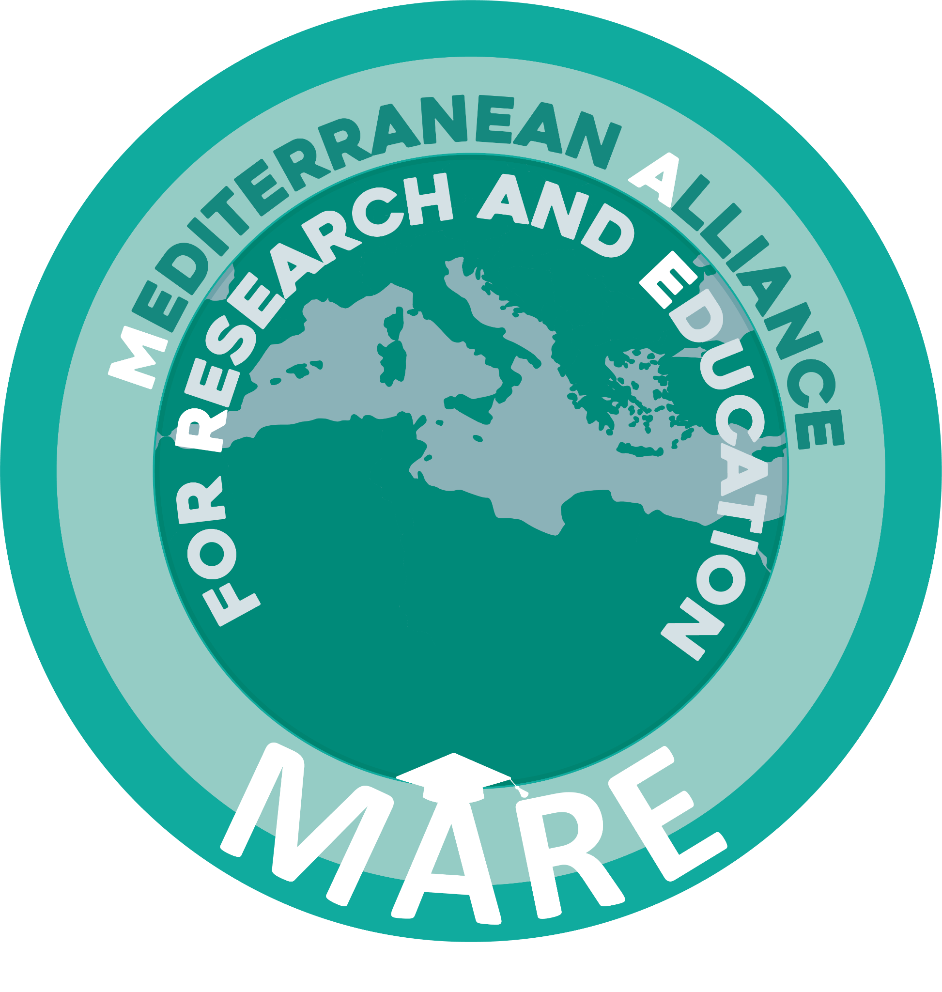
PNRR M4 C1 INV.3.4 SUB-INV.T4 - TNE D.D. n. 167 dated 03/10/2023
Projet “MARE” CUP: B71I24000240006

APPLICATION FORM

Please complete the form below and attach the required documents before submitting your application.
Submit your application by no later than 4 December 2025 (23:59, Tunisian time) by e-mail at the following address Advanced.skills.course@isce.ucar.tn specifying in the subject line “Application for MARE Advanced Skill Course”.

Personal Information

1. First Name: ..............................................................................................................................
2. Surname: .................................................................................................................................
3. Date of Birth (dd/mm/yyyy): ...................................................................................................
4. Nationality: ..............................................................................................................................
5. Gender: ☐ Woman ☐ Man ☐ Prefer not to say
6. Email address: ...........................................................................................................................
7. Phone number (with country code): .........................................................................................
8. Profession: .................................................................................................................................
9. University: ..................................................................................................................................

language skills
Indicate your level of English proficiency according to the Common European Framework of Reference for Languages (CEFR).

☐ B2 ☐ C1 ☐ C2 ☐ Native/Bilingual

Required documents
Please ensure that the following documents are attached to your application:

□ Curriculum Vitae
□ Motivational letter
□ ID (identity card or passport for Algerian students)

Applicant’s statements

Under my own personal responsibility and fully aware of the criminal penalties provided for in the event of false declarations or the submission of false documents,

I hereby declare that

1. All the information and copies of documents provided are true;
2. I am aware that incomplete or late submitted applications will not be assessed;
3. I do not hold any grant funded by European Union;
4. I authorize the processing of my personal data in accordance with the applicable Tunisian legislation.

Should my application be successful

I commit to

- Fully attending the Advanced Skill Course “Advancing Education for Sustainable Development and Global Citizenship in the Mediterranean Context”;
- Complying with all administrative procedures required by the University of Carthage, University of Bologna and Tunisian Government;
- Reimbursing the full cost of travel and accommodation incurred on my behalf in case of a late withdrawal (only for Algerian students)

Date of Submission: ___ / ___ / ______

Signature: ______________________________________

